-A401-Asia-China-Liangzhu-D Shaped Device-Taotie- Shaman with Feather Headdress-Jade–Mid Liangzhu Period-3000-2600 BCE





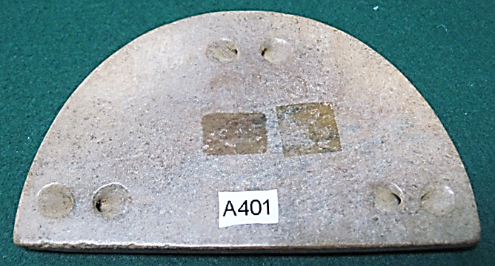

Figs. 1-3. China-Liangzhu-D Shaped Device-Taotie- Shaman with Feather Headdress-Jade–Mid Liangzhu Period-3000-2600 BCE

Case no.: **5**

Accession Number: **A401**

Formal Label: China-Liangzhu-D Shaped Device-Taotie- Shaman with Feather Headdress-Jade–Mid Liangzhu Period-3000-2600 BCE

Display Description:

This Liangzhu Culture “D”-shaped device, is a flat, relatively thick (.265 in, 6.74mm) jade with three blind perforations in the obverse. On the reverse it has a bas-relief, engraved Taotie motif (a bi-laterally symmetrical animal mask probably of a wild boar) surmounted by a bas-relief, engraved shaman with a feather headdress, who has mastery, literally, over his animal spirit below.

This iconography undoubtedly has its origins in the Paleolithic Period when shamanic imagery characterized the symbolism of hunter-gatherers who depended on wild boars and antelope for part of their sustenance (see Biot 1851).

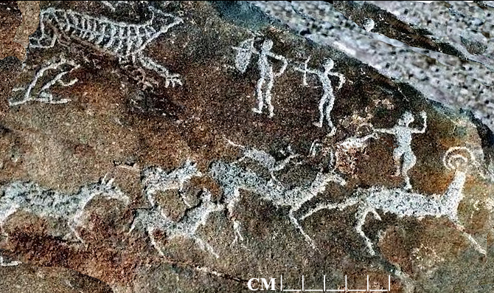

Fig. 4. Two Paleolithic male archers have just killed a wild boar, which lies on its side with an arrow in its left, rear flank. Above the boar is a tiger that has been attracted to the kill and is threatening the archers. The archers are depicted in the split second when they have just released the bowstring with their left hands and with their right hands still on the anchor point on the face of the bow when it was at full draw. Below is a small herd of antelope with a buck leading two cows and four calves of which the one furthest to the right has been caught by the horns by a woman (identified by her wide hips). Photo taken in the Helanshan, 15-8-1998.

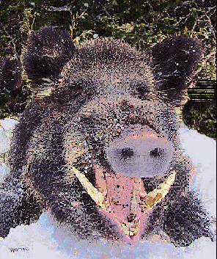 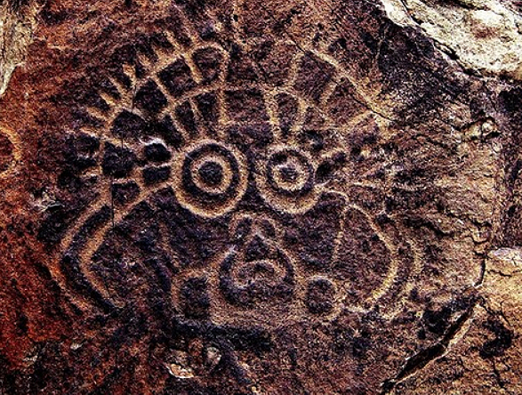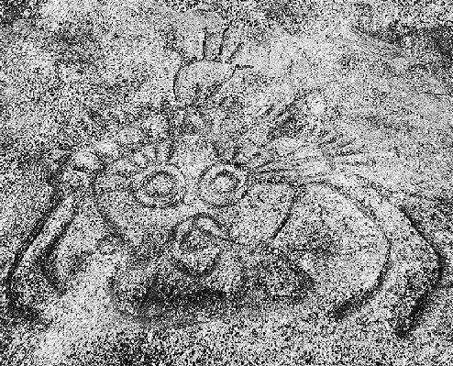

Fig. 5. Chinese wild boar (Sus scrofa) photo after [Huntercourse.com](http://www.huntercourse.com/blog/2011/11/the-worlds-most-dangerous-game-to-hunt/).

Fig. 6. Petroglyph of a Taotie or anthropomorphic animal mask (probably of a wild boar) from the Helankou site in the Helanshan, Ningxia Province, China, after <https://www.researchgate.net/figure/Face-like-motif-at-the-Helankou-site-Helan-Shan-Ningxia>.

Fig. 7. Petroglyph of a Taotie or anthropomorphic animal mask (probably of a wild boar) from the Helankou site in the Helanshan, Ningxia Province, China, 15-8-1998. Figs. 5-6 masks have two appendages or arms that extend down from a feather headdress suggesting that an anthropomorph, possibly a shaman, is behind the mask.

The Taotie was developed as a symbolic anthropo-zoomorphic mask of the premier hunted animal, the wild boar, of late Paleolithic China that Neolithic settlers domesticated. As a religio-theatrical mask it was probably used in rituals that portrayed the wild boar as a hunted figure that was formidable when cornered or when its piglets were in danger. However, we have no written records of these rituals so they remain hypothetical reconstruction from “rock art” and artistic portrayals, although the scenario is entirely reasonable when considered in a comparative, anthropological *Weltanschauung.*

Thus, Taotie imagery was pecked and engraved in a variety of petroglyph panels throughout northern China, especially those in the Helanshan of Ningxia Province. These masks were so widely acknowledged and elaborated that they formed the foundational imagery of a shamanic, mythic anthropo-zoomorphic being that resonated through various Chinese cultures from the Paleolithic through the Shang Dynasty.

The continuity of the Taotie image to is putative presence in the late Shang Dynasty suggests its commonality with images in the *Shan Hai Jing* (山海经, “Scripture of the Mountains and the Seas”). The *Shan Hai Jing* is an important collection of myths, mythic beings and mythic places which adumbrates the conceptualization process of forming Paleolithic Taotie petroglyphic images and the continuity of these images on rock with the Neolithic images on jade. Indeed, this transference to jade has a special connection with astrology. The first part of the *Shan Hai Jing* mainly deals with nature (mountains, plants, animals and minerals) and probably originated as Daoist essays, ca 300 BCE-200 BCE. The second part deals with remote areas and their alien inhabitants and animals and probably originated as a pastiche of Daoist travelers’ tales, ca 200-100 BCE.

[The collecting of the various, disparate sections of the *Shan Hai Jing*’s first two of four main parts have been attributed to Emperor Yu 禹, the founder of the Xia dynasty 夏 (2070-1600 BCE) or his minister Bo Yi 伯益. However, the process of editing these disparate sections has been dated to the late Warring States 戰國 (475-221 BCE) and Han 漢 (206 BCE-220 CE) when scholars Liu Xiang 劉向 or Liu Xin 劉歆 of the Former Han period 漢 (206 BCE-8 CE) were adding supplements compiled, which were corroborated by Shuifu xianbo 水府 仙伯, "Immortal Master of the Water Realm" otherwise known as Guo Pu 郭璞 (276-324), author of the *fengshui* (風水 "wind and water") classics, Zangshu 葬書 (“The Book of Burials”: using wind and water energy to determine the correct placement of tombs to pacify the corpse and profit the living) and Yuzhao dingzhen jing 玉照定真經 ("Jade According to the True Scriptures," a book on astrology) (Gao Riguang 高日光 (1996), "Guo Pu 郭璞", in Feng Kezheng 馮克正, Fu Qingsheng 傅慶升 (ed.), *Zhuzi baijia da cidian* 諸子百家大辭典 (Shenyang: Liaoning renmin chubanshe), p. 86). (Xueqin 李學勤 and Wenyu 呂文鬰 1996, 2: 1784)].

By the Mid-Liangzhu Phase (3000-2600 BCE) Liangzhu culture achieved a high point of early cultural, engineering and economic development in a city with a size of about 300 ha that involved highly developed groups of artists, hydraulic engineers and business executives.

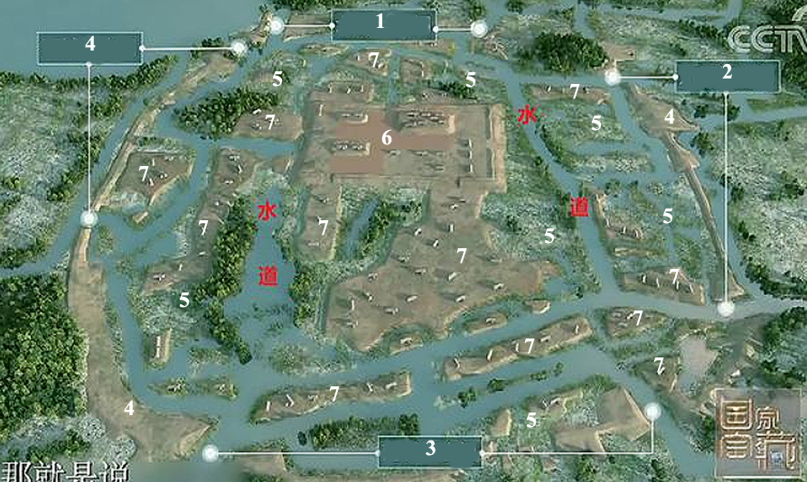

Fig. 8. This is an artist’s model of the 3000 BCE, 300 ha, **Liangzhu city. It** displays the rammed-earthen perimeter wall (4), the central, rectangular, 10 m-high, 3 ha Mojiaoshan 莫 角 山 ritual center and smaller, rammed-earthen residential and jade and ceramic atelier platforms (7), some of which were constructed of fired adobe bricks. The centrality of the Mojiaoshan platform (6) reflects the unprecedented Neolithic social cohesion of **Liangzhu**. This cohesion enabled the communal management of large-scale hydraulic engineering projects, including the construction of reservoirs, levees, and dams that facilitated protection from flooding, dredged canals (1-3) that made possible improved transportation and extensive irrigation canals (5) that augmented rice production for a growing population (Liu 2017). After an artist’s conceptualization: <http://p3.pstatp.com/large/616100014bf6036976ba>.

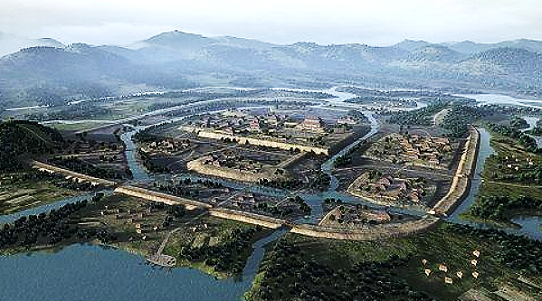

**Fig. 9.** This is an artist’s perspective drawing of the 3000 BCE, 300 ha, **Liangzhu city. It** displays the rammed-earthen perimeter wall, the central, rectangular, 10 m-high, 3 ha Mojiaoshan 莫 角 山 ritual center and smaller, rammed-earthen residential and jade and ceramic atelier platforms, some of which were constructed of fired adobe bricks. The centrality of the Mojiaoshan platform reflects the unprecedented Neolithic social cohesion of **Liangzhu**. This cohesion enabled the communal management of large-scale hydraulic engineering projects, including the construction of reservoirs, levees, and dams that facilitated protection from flooding, dredged canals that made possible improved transportation. Extensive irrigation canals augmented rice production for a growing population (Liu 2017). [**http://p3.pstatp.com/large/615f00050b7a0d5bc064**](http://p3.pstatp.com/large/615f00050b7a0d5bc064).

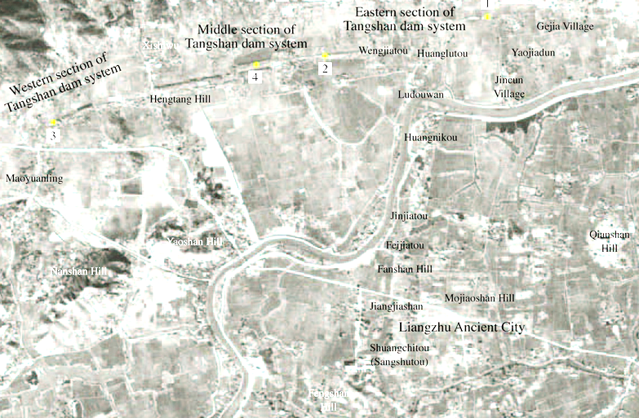

Fig. 10. Liangzhu complex with subsidiary sites and dams after https://www.degruyter.com/view/j/char.2016.16.issue-1/char-2016-0010/graphic/j_char-2016-0010_fig_002.jpg

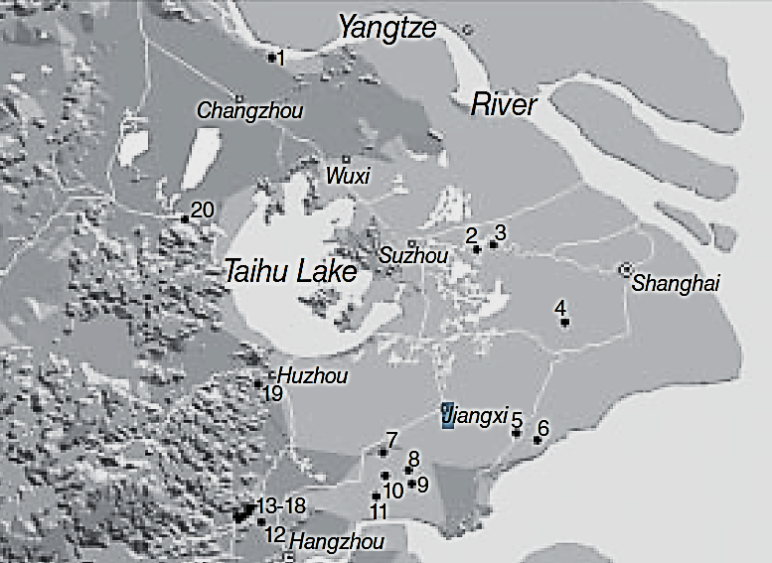

Fig. 11. Detail of major Middle Liangzhu associated sites. After Zhou Ying 2007.

1, Gaochengdun 高 城 墩; 2, Zhaolingshan 赵 陵 山; 3, Shaoqingshan 少 卿 山; 4, Guangfulin 广 富 林; 5, Pingqiudun 平 丘 墩; 6, Daimudun 戴 母 墩; 7, Xindili 新 地 里; 8, Pu’ anqiao 普 安 桥; 9, Zhangjiabang, 赵 家 浜, Xujiabang 徐 家 浜; 10, Heyedi 荷 叶 地; 11, Xubuqiao 徐 步 桥; 12, Miaoqian 庙 前; 13–18, Yaoshan 瑶 山, Fanshan 反 山, Huiguanshan 汇 观 山, Boyishan 钵 衣 山, Shangkoushan 上 口 山, Mojiaoshan 莫 角 山; 19, Yangjiabu 杨 家 埠; 20, Yannan 堰 南.

A suite of expertly designed and manufactured jade objects in élite burials provide a glimpse of the élite artisans who conceptualized and executed mythological, religious and ideological symbols into jade artifacts.

This symbolism had evolved from a hunter-gatherer shamanic background into an animal husbandry of domesticated wild boars, that played an important economic and symbolic rôle in the development of Liangzhu culture.

Archaeological artifacts from the Mid-Liangzhu Phase (3000–2600 BCE) mostly came from the following sites (Fanshan, Gaochengdun 高 城 墩, Nanjing and Jiangyin 2009, Yaoshan, Zhaolingshan burial M77, Shaoqingshan 少 卿 山, Suzhou Museum 1988, and Guangfulin 广 富 林, Shanghai Archaeology 2008). However, the provenance of the current artifact is uncertain and so is given with the GPS coordinates of the original Liangzhu site.

**LC Classification:** NK5750.2.A1

**Date or Time Horizon:** Mid-Liangzhu Period-3000-2600 BCE

**Geographical Area:** Liangzhu culture, lower Yangtze River delta

Maps:



Fig. 12. China, Neolithic Period, ca. 8000 - ca. 2000 BCE after https://etcweb.princeton.edu/asianart/assets/map_china_neolithic.gif

**GPS coordinates: ca** N 30°24', E 120°

**Cultural Affiliation**: Liangzhu culture, lower Yangtze River delta, 3300-2250 BCE

**Medium:** Jade

**Dimensions:** H 2.12 in, 53.79 mm; L 3.6 in, 91.34 mm

**Weight:**

**Condition:** original

**Provenance:** Yuhang County, Zhejiang Province

**Discussion:**

DNA from Liangzhu culture sites around Taihu Lake exhibit high frequencies of Haplogroup O1 which was absent in other archaeological sites that were sampled inland of the Liangzhu Complex. Haplogroup O1 is common to modern Austronesians and Taiwanese Austronesians (TAN) (Li *et al*. 2007). O1 probably came from those Liangzhu Austronesians (LAN) who had been displaced from the mouth of the Yangtze River delta by an economic crash of the LAN ca 4500 BCE possibly induced by a meteor that struck at the present location of Taihu Lake, a meteoric crater (Erkang *et al*. 2002). Recent studies show that special micro-fractures in quartzite were formed during the unloading process after the compression at the peak of an impact event (Wang, Wan, Xu 2002). Bayesian phylogenetic analysis allows us to reconstruct a history of early Austronesians arriving in Taiwan in the north ~4,000 BCE, spreading rapidly to the south due to this catastrophic event (Ko *et al*. 2014). Those LAN culture sites that reformed round Taihu Lake took 800 years, from 4200 BCE until 3400 BCE, to recover at the Early LAN Period. Later, ca 2200 BCE at the Late LAN Period, a series extreme floods from diversions of the Yangtze River indicated by intrusions of mud and sand into the cultural layers of Late LAN Period sites mark this event and a second wave of LAN emigrating to Taiwan. Subsequently, one trajectory of TAN migrants began to sail east via the Buka Strait in the Solomon Islands, which became a staging area for the populating of Polynesia ca. 2000 BCE (Ko *et al*. 2014).

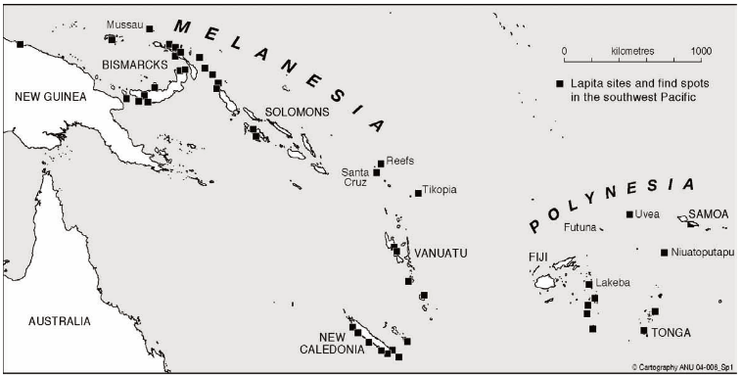 Fig. 13. Lapita Ceramic Culture sites in the Pacific 1250-650 CE after Spriggs 1997: Figure 4.

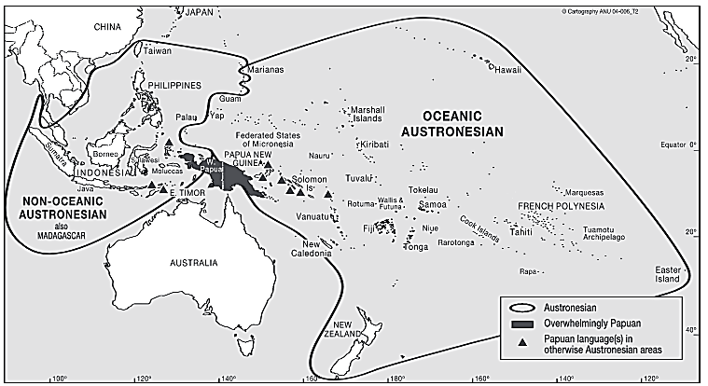

Fig. 14. Papuan and Austronesian Language Areas (Tryon 2016 Map 2) (Tryon, Darrell. 2016. The Languages of Bougainville. In Regan, A.J. and Griffin, H.M. *Bougainville before the conflict*. Sidney, ANU Press, Map 2).

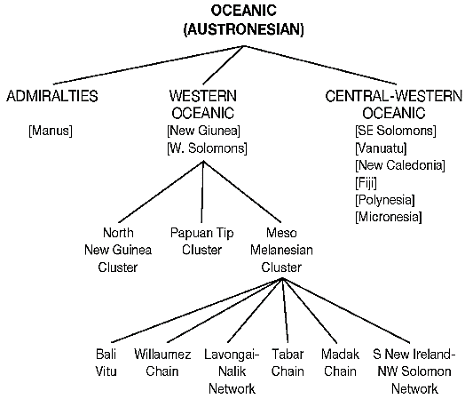

Fig. 15. Other trajectories of AN migrants migrated north to Luzon in the Philppines and west to Madagascar (Hung 2005 a,b).

**References:**

Biot, Jean Baptiste. 1851. *Le Tcheou-li: ou, Rites des Tcheou.* Paris: Imprimerie nationale, 1851. 3v.

Chang, K.C., Xu, P. and Lu, L. 2005. *The formation of Chinese civilization: an archaeological perspective*. New Haven: Yale University Press.

Childs-Johnson, Elizabeth. 1988. *Ritual and Power: Jades of Ancient China*. New York: China House Gallery, China Institute in America.

Childs-Johnson, Elizabeth. 2009. “The Art of working Jade and the rise of civilization in China.” In Elizabeth Childs-Johnson, *Early Chinese jades in American Museums*. Beijing: The Science Press, China Science and Technology Publishing and Media Co., Ltd., 2009, pp. 291-393.

Erkang, Wang, Yuqiu Wan, Shijin Xu. 2002. “Discovery and implication of shock metamorphic unloading microfractures in Devonian bedrock of Taihu Lake,” *Science in China Series D: Earth Sciences*, 45 (5): 459–467.

Gu Fang. 2005. *Complete collection of unearthed jades in China*. 15 v. Beijing: China Science and Technology Publishing and Media Co., Ltd.

Hayashi, Minao. 林巳奈夫. 1991. Chūgoku kogyoku no kenkyū. 中國古玉の研究. Tōkyō: Yoshikawa Kōbunkan; 東京: 吉川弘文館, 1991.

Hayashi, Mineo. 林巳奈夫. 1990. “On the Chinese Neolithic jade Tsung/Cong,” *Artibus Asiae*, 50(1/2):5-22.

Hayashi, Mineo. 林巳奈夫.1973.  *Toyo Gakuho* [*Journal of the Research Dept. of the Toyo Bunko*] 45:1-57.

Hung, Hsiao-Chun. 2005a. The culture interaction between Taiwan and adjacent islands—the origins and dispersal of Austronesian-speaking peoples, in *The Archaeology of Southeast Coastal Islands of China Conference*: 249–269, ed. Jonas Chung-yu Chen and Jian-Guo Pan. Taiwan: Mazu County Government (in Chinese).

Hung, Hsiao-Chun. 2005b. Neolithic interaction between Taiwan and northern Luzon. Journal of *Austronesian Studies* 1(1): 108–133.

Kezheng, Feng, 馮克正, and Fu Qingsheng, 傅慶升, eds. 1996. *Zhuzi baijia da cidian* 諸子百家大辭典 (“Hundred Emperors’ big dictionary”). 辽宁人民出版社, Shenyang Shi: Liaoning ren min chu ban she anshe.

Ko, A.M.S., Chen, C.Y., Fu, Q., Delfin, F., Li, M., Chiu, H.L., Stoneking, M. and Ko, Y.C., 2014. “Early Austronesians: into and out of Taiwan,” *The American Journal of Human Genetics*, *94*(3): 426-436.

Laufer, Berthold. 1912. *Jade: a study in Chinese archaeology and religion.* Field Museum of Natural History, Publication 154, Anthropological series, vol. X. Chicago.

Li, Hui; Huang, Ying; Mustavich, Laura F.; Zhang, Fan; Tan, Jing-Ze; Wang, Ling; Qian, Ji; Gao, Meng-He; Jin, Li. 2007. "Y chromosomes of prehistoric people along the Yangtze River," *Human Genetics* 122: 383–388.

Tryon, Darrell. 2016. “The Languages of Bougainville.” In Regan, A.J. and Griffin, H.M. *Bougainville before the conflict*. Canberra: ANU Press, pp.

Liu, Bin, Ningyuan Wang, Minghui Chen, Xiaohong Wu (吴小红), Duowen Mo, Jianguo Liu, Shijin Xu, and Yiji Zhuang. 2017. Earliest hydraulic enterprise in China, 5,100 years ago. *Proc*

*Natl Acad Sci USA* 114:13637–13642.

Wenbao, Lu. 1998. “Cong-shaped bead.” In Liangzhu Culture Museum, ed., *The dawn of Chinese civilization: Jades of the Liangzhu culture.* Hong Kong: Liangzhu Culture Museum and The Art Museum, The Chinese University of Hong Kong.

Wu, Li. 2014. "Holocene environmental change and its impacts on human settlement in the Shanghai Area, East China," *Catena* 114: 78–89

Li Xueqin 李學勤, Lü Wenyu 呂文鬰 (1996). *Siku da cidian* 四庫大辭典. Changchun: Jilin daxue chubanshe.

Zhejiang [ 浙 江 省 文 物 考 古 研 究 所]. 2003. 瑶 山 (*Yaoshan Site*). Beijing: Wenwu.

Zhejiang [ 浙 江 省 文 物 考 古 研 究 所]. 2005a. 反 山 (*Fanshan Site*). Beijing: Wenwu.

Zhejiang [ 浙 江 省 文 物 考 古 研 究 所]. 2005b. 良 渚 遗 址 群 (*Liangzhu Site Group*). Beijing: Wenwu.

Zhejiang [ 浙 江 省 文 物 考 古 研 究 所]. 2008. 杭 州 市 余 杭 区 良 渚 古 城 遗 址 2006–2007 年 的 发 掘 (Excavation of the Liangzhu Ancient City Site 2006–2007 at Yuhang of Hangzhou). *Kaogu* 2008 (7): 3 – 10.

Zhang, Chia; Hsiao-Chun, Hung. 2008. "The Neolithic of Southern China–Origin, Development, and Dispersal," *Asian Perspectives*. 47:2, 309–310.

|  |
| --- |
| Zhou Ying. 2007. 东方文明的曙光: 良渚遗址与良渚文化 = Dong fang wen ming de shu guang: Liang zhu yi zhi yu liang zhu wen hua = *The Dawn of the Oriental Civilization: Liangzhu site and Liangzhu culture.* Beijing: China Intercontinental Press. |